Lab 7 Cross-Site Request Forgery Attack

Shiqi Wang
10/25/2012
CIS643 Computer Security

Lab Tasks

Task1
Choose seed as the target. Login as admin, set a password for seed, then login as the seed.
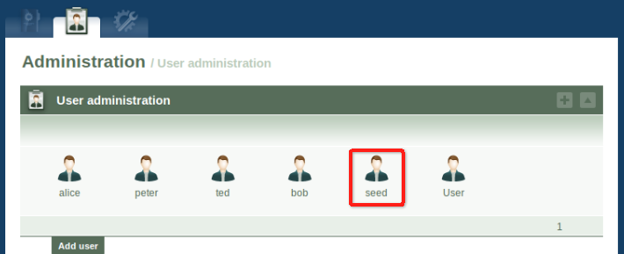
Edit the profile of seed
Company is “Syracuse University”
E-Mail is “seed@syr.edu”
